EX. NO: 1

IMPLEMENTATION OF CAESAR CIPHER

AIM:
To implement the simple substitution technique named Caesar cipher using C language.
ALGORITHM:
STEP-1: Read the plain text from the user.
STEP-2: Read the key value from the user.
STEP-3: If the key is positive then encrypt the text by adding the key with each
character in the plain text.
STEP-4: Else subtract the key from the plain text.
STEP-5: Display the cipher text obtained above.
PROGRAM:
#include <stdio.h>
#include <string.h>
int main()
{
char text[100], encrypt[100], decrypt[100];
int key, i;
printf("Enter the message (UPPERCASE): ");
scanf("%s", text);
printf("Enter the key: ");
scanf("%d", &key);
// Encryption
for(i = 0; text[i] != '\0'; i++)
{
encrypt[i] = ((text[i] - 'A' + key) % 26) + 'A';
}
encrypt[i] = '\0';

printf("Encrypted Text: %s\n", encrypt);
// Decryption
for(i = 0; encrypt[i] != '\0'; i++)
{
decrypt[i] = ((encrypt[i] - 'A' - key + 26) % 26) + 'A';
}
decrypt[i] = '\0';
printf("Decrypted Text: %s\n", decrypt);
return 0;
}
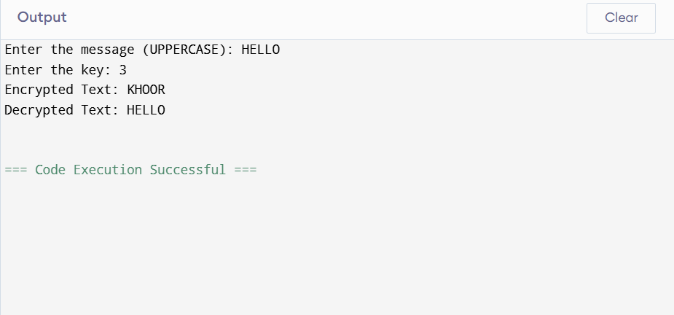
Result:
Thus the implementation of Caesar cipher had been executed successfully.

